 | Scoil an Chroí Ró Naofa Íosa  Class: Sixth | 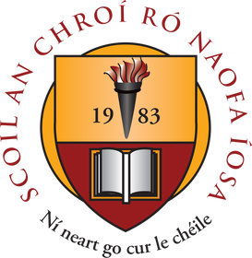

Suggested Work

Activities and Projects
task | Description
Master your Maths | Next 3 weeks (1 per day)
Busy at Maths | Capacity (p172), Weight (p162), 3D shape (p.168) Read, explore and complete activities
Just Grammar | Next 4 pages (follow on from page marked)
Spellbound | Next 3 weeks
Irish | Revise ALL verbs (3 tenses) and Re-read vocabulary lists
Religious Ed | My Confirmation book – Learn Mass responses.
Music | Listen to the next composer available.

Novel and Reading
task | Description
Book reviews | Read two novels of choice (hardcopy or online) Complete two book reviews
Project: A country of choice | Explore a country of the world and complete a project (slideshows or online presentations are encouraged where possible). Examine the following key features:  1. General Facts. 2. Famous tourist sites. 3. Famous People. 4. Geographical features (rivers, lakes, mountains etc). 5. Industry and economy.

Online Material
- Twinkl online (open access) Owford owl online (novels and reading material)
- Khan Academy GoNoodle (online exercises and movement breaks)
- Scoilnet Jo Wicks body coach online
- E-Leathanach Classics for Kids
- Seidean Sí (6th) Kahoot online

