 | Scoil an Chroí Ró Naofa Íosa  Class: Fifth | 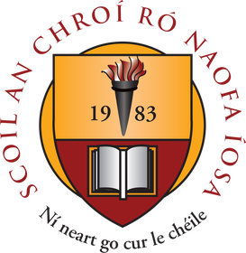

Suggested Work

Activities and Projects
task | Description
Master your Maths | Week 24 and 25 Revise ALL multiplication and division tables.
Busy at Maths | Look Back (p119), Chapter 23 Directed Numbers, Chapter 25 Weight
Just Grammar | Next 3 pages (follow on from page marked)
Spellbound | Units 24, 25 and 26
Irish | Revise ALL verbs (A.C and A.L)
SPHE | Friendship activities on Twinkl
Music | Listen to the next composer available.

Novel and Reading
task | Description
Up and Running | Read and complete activities: ‘The Hat’ and ‘The Superglue’. Complete two book reviews based on library books of your choice (online books also available)
Project: The Famine  Planet Earth in Space  The Human heart | Explore these topics and create an interesting presentation of facts.

Online Material
- Twinkl online (open access) Owford owl online (novels and reading material)
- Khan Academy GoNoodle (online exercises and movement breaks)
- Scoilnet Jo Wicks body coach online
- E-Leathanach Classics for Kids
- Seidean Sí (5th) Kahoot online

