Scoil an Chroí Ró Naofa Íosa
Huntstown Dublin 15
My SPring Project 2020

Learning at home

Project work
History
Choose your area and your level and try some of the activities below. You can choose to upload your material to this document or present it in a style more suited to your needs. We welcome your projects once completed at the following address
sacredheartspring2020@gmail.com
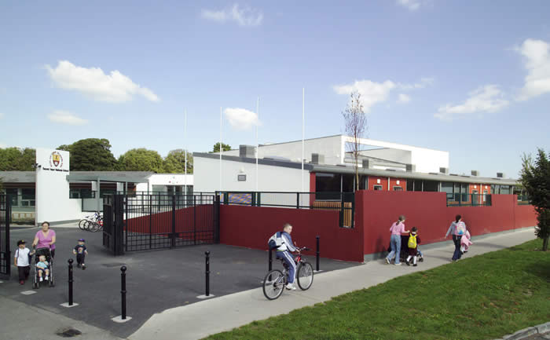

Primary Sources :
- Interview parents / grandparents / relatives about their schooldays, their holidays and where they grew-up.
- Examine photos / scrapbooks / diaries / old copies and compare to their own.
- Research favourite music from a particular year / time.
- Visit a historic site e.g. Mulhuddart Church and Burial Ground. OBSERVE SOCIAL DISTANCING AND ALL H.S.E. AND GOVERNMENT GUIDELINES
Secondary Sources:
1. Research articles about their topic, on-line library, internet.
Reading:
1. Historic maps of the area, these may only be 5 years old!!
2. Novels relating to a particular time or area.
3. Reports / records on Internet.
4. Reading letters, diaries.

Writing:( English & Irish )
- Labelling their drawings / diagrams.
- Creating Timelines.
- Writing reports on their research.
- Creating stories based in an area or specific time, referencing setting and historic detail.
Art:
- Sketching / Painting a scene, section of a building or a building.
- Taking photos.
- Making 3D Models.

