TYRRELSTOWN PARK
BY
LENNON SWEENEY
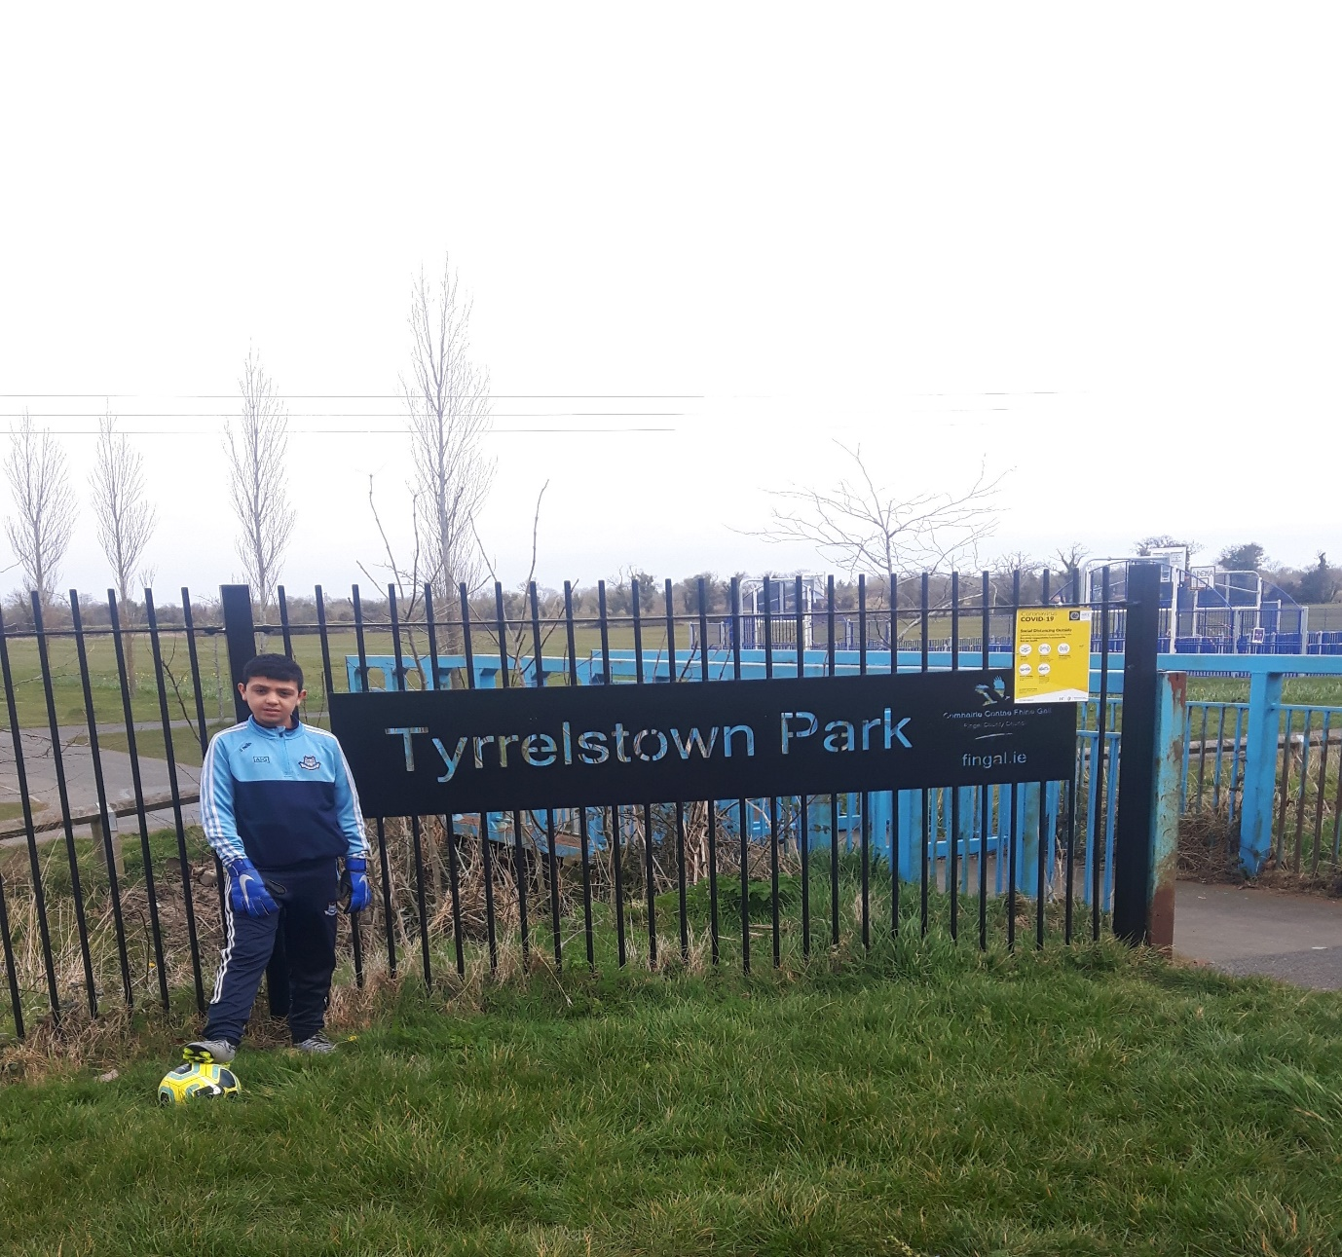

My local park is in Tyrrelstown.
It is a very nice park.
It is very close to my house, It takes me 40 seconds to walk over.
The park is 140 metres from my house.

Here is a list of amenities that is in the park:

- Playground
- Pond
- Astro pitch
- Basketball court
- Soccer pitch
- GAA pitch
- Exercise equipment

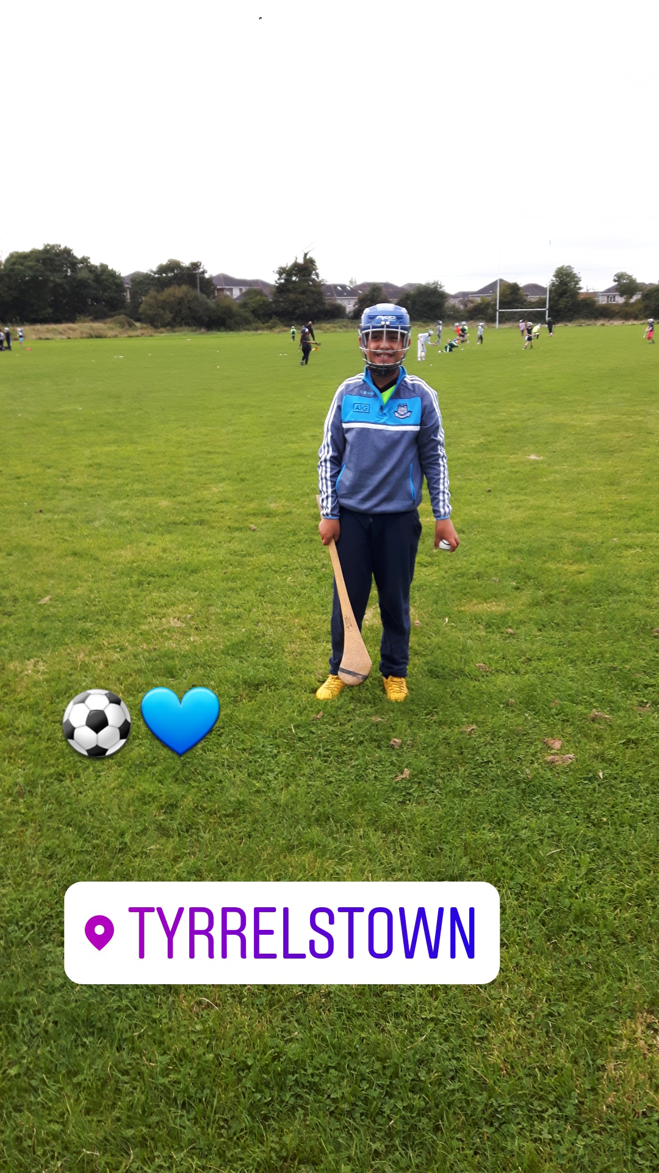

This is the GAA pitch in the park.
We play our GAA home games on this pitch.
The length of the pitch is 100 metres.
I can sprint the length of the pitch in 26 seconds, my Mam timed me on the stopwatch.

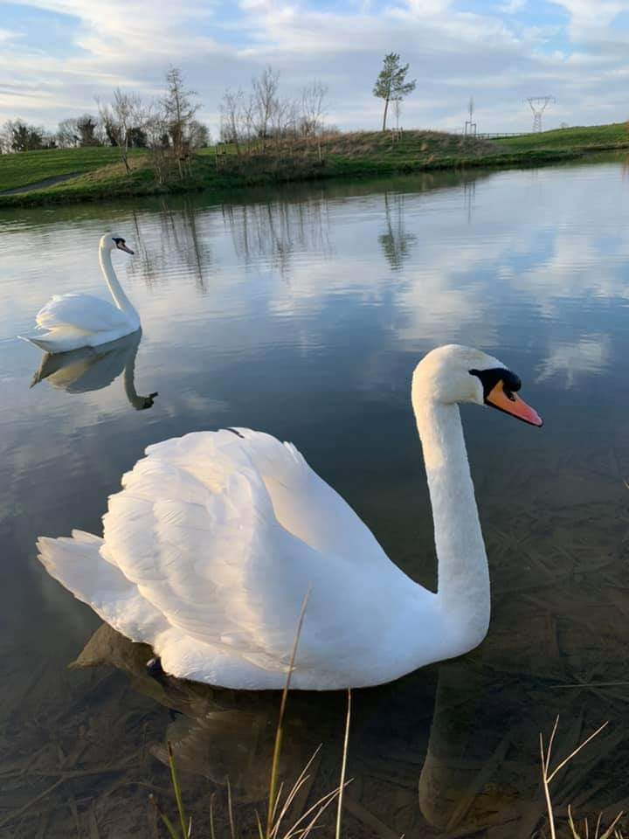

This is the pond in Tyrrelstown Park.
Me and my mam took this picture of the swan in the pond last year.
Swans have no teeth they have beaks instead.
They use their beaks for catching and eating.
Swans eat small plants, fish, frogs and worms.
TYRRELSTOWN MAP



