Learning at home

Useful resources
Here are some useful websites and Apps that might help you with your learning at home. There is a brief description beside each one, giving ideas as to how they might be used.
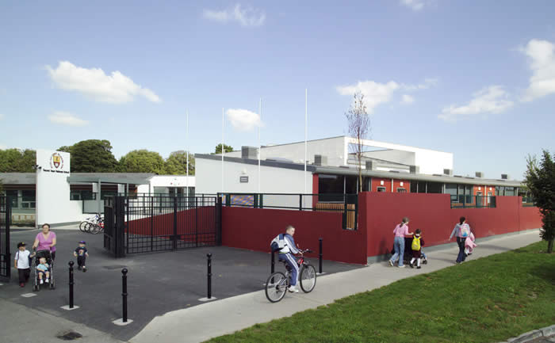
Site / App | Useful for: | Notes
- https://www.autodraw.com/ | Drawing and illustrating. | Easy to use app suitable for all class levels. Share ideas and creative responses to text.
- http://www.askaboutireland.ie/ | Exploring articles, maps and E-Books related to Ireland and Irish culture | Suitable mainly for students 3rd – 6th. Great for creating projects. Read and explore ideas together.
- Adobe Spark | Creating stunning projects and online presentations. Making visual stories. | Suitable for classes 1st – 6th. Read a story together and create a digital response.
- Booktrust.org | Exploring a selection of E-Books
- https://www.bbc.com/bitesize/articles/z3c6tfr | BBC typing mat. Developing your keyboard and typing skills through games and fun activities | Great for students who prefer to type their work rather than write.
- https://www.teachingvisuallyimpaired.com/cause--effect-apps.html | Exploring activities for visually impaired students.
- http://plasq.com/apps/comiclife/macwin/ | Developing comic books online. Adding pictures and text to create your own fun comic. | Suitable for students 3rd – 6th.
- http://www.codeweek.it/codyroby/ | Coding and programming. Download the cards and play the game with friends and family.
- https://describingwords.io/ | Helping to find words to describe nouns and make your stories more inventive and creative. | Suitable for classes 1st – 6th.
- https://info.flipgrid.com/ | Recording your ideas using your voice rather than text. Share your reflections with others. | Suitable for all class levels.
- https://www.kodable.com/ | Coding and programming online. Great fun to be had as you move characters around the screen in inventive ways. | Students in the senior classes will enjoy this site. It can be accessed on tablets and laptops.
- https://www.memrise.com/ | Learning languages in a fun and easy manner. | Useful for students who use English as an additional language.
- https://www.mathplayground.com/ | Exploring number in Mathematics. Playing number games. | All class groupings can find activities here.
- Math Fight | Revising tables and number facts. | Only available for use on IPad and Android Tablets. Suitable for students 1st – 6th.
- https://lightbot.com/flash.html | Coding and programming. Make the robot follow the correct path. Relies on logic and problem solving.
- https://www.nessy.com/us/ | Enhancing literacy | Specially designed to support students who have been diagnosed as being Dyslexic.
- https://nzmaths.co.nz/ | Developing problem solving in Mathematics | All class levels can access this resource.
- https://www.tynker.com/ | Coding and programming. Looks a lot like Minecraft and allows students to create amazing adventures online

