Scoil an Chroí Ró Naofa Íosa
Huntstown Dublin 15
My SPring Project 2020 (No.2)

Learning at home

Project work
English
Why not explore an area that piques your interest? Take a look at the ideas below and use the template to design your own English project. We would love to hear from you using the email address below.
sacredheartspring2020@gmail.com
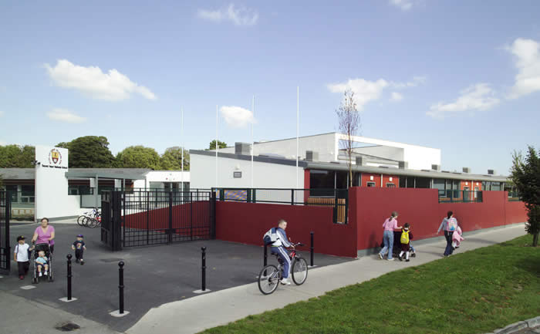

English Activities:
*Choose your area and level.
Oral:
1. Turn-taking in conversation.
2. Reporting.
3. Describing.
4. Stating an opinion / preference.
5. Learning / using new vocabulary.
6. Creating imaginative stories.
Aural:
1. Differentiating different sounds
2. Identifying different sounds
3. Listening to stories.
4. Creating rhyming words.
Reading:
1. Listening to stories.
2. Retelling the pictures and retelling the story.
3. Using Fact Books / Articles to identify relevant information.
4. Reading Novels relating to the Topic.
5. Using a Dictionary to locate meaning and spelling of new vocabulary.
Writing:
- Labelling Pictures/Diagrams/Models.
- Making lists and action plans.
- Alphabet Lists.
- Letters / emails to family / friends / Radio / Printed Media.
- Reports on observations / trips.
- Instructions for model making.
- Recipes for Wildlife Foods.
- Writing a short story, set in 2020, 2000, 1980, 1800’s
- Writing a short play, characters, a robin & a blackbird, two people meeting at Lady’s Well in the 1800’s, a Tidy-Town/Fingal Co.Co. worker and a Graffiti Writer.
  - A Travel Guide to Fingal’s historic Monuments.
  - Request to National Aquatic Centre for FREE entry to all school children.
Poetry:
Reading Poetry.
Listed below are examples of the beauty, humour and simplicity of poetry. A few words can be used to say such a lot and when we memorise them we have a message and a party piece. If you have a book of poems explore it, if not try our Blanchardstown Library on-line otherwise try the internet. Your efforts will be rewarded.
1. RAIN by Spike Milligan
There are holes in the sky Where the rain gets in, But they're ever so small, That's why rain is thin.
2. THE CATERPILLAR by Christina Rossetti
Brown and furry, Caterpillar in a hurry; Take your walk To the shady leaf or stalk. May no toad spy you, May the little birds pass by you; Spin and die,
To live again a butterfly.
3. I'M GLAD THE SKY IS PAINTED BLUE, Anon.
I'm glad the sky is painted blue, And the earth is painted green, With such a lot of nice fresh air All sandwiched in between.
4. AT THE ZOO by William Thackeray
First I saw the white bear, then I saw the black; Then I saw the camel with a hump upon his back; Then I saw the grey wolf, with mutton in his maw; Then I saw the wombat waddle in the straw; Then I saw the elephant a-waving of his trunk; Then I saw the monkeys — mercy, how unpleasantly they smelt!
Writing Poetry.
Writing poetry throughout the Primary school - Scoilnet
www.scoilnet.ie › fileadmin › user_upload › writing_poetry
Poetry Writing Lessons for Kids - Kenn Nesbitt's Poetry4kids.com
www.poetry4kids.com › lessons › poetry-writing-lessons
1. A List Poem. 2. An Alphabet Poem. 3. A Shape Poem 4. A Limerick. 5. A Rhyming Poem, 6. A Kennings Poem 7. A Cinquain Poem. 8. A Free Poem 9. A Haiku Poem 10. A Diamante Poem
Spellings:
“Look, Say, Cover, Write, Check”
- Select a range of words which are of interest to you.
- Can you create a Rhyming list with 1 of these words e.g, Bug, Hug, Jug, Tug, Mug.
- Can you create a Word Search / Sentences using these new words.
- Can you use your word list to create compound words.
- Can you use your word list to create NEW words. Think Roald Dahl but remember to give a definition of the word, what it means,
E.g. Huntstown,.....Huntsfun: having a funtime searching of bugs and invertebrates in Huntstown.

