Art Project 2020
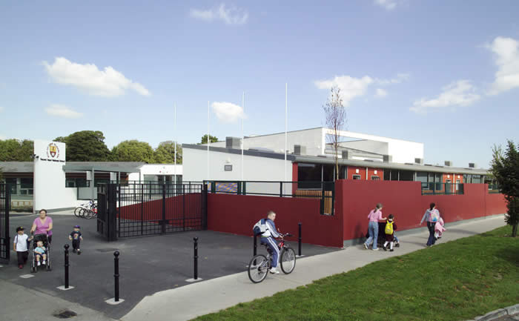 | 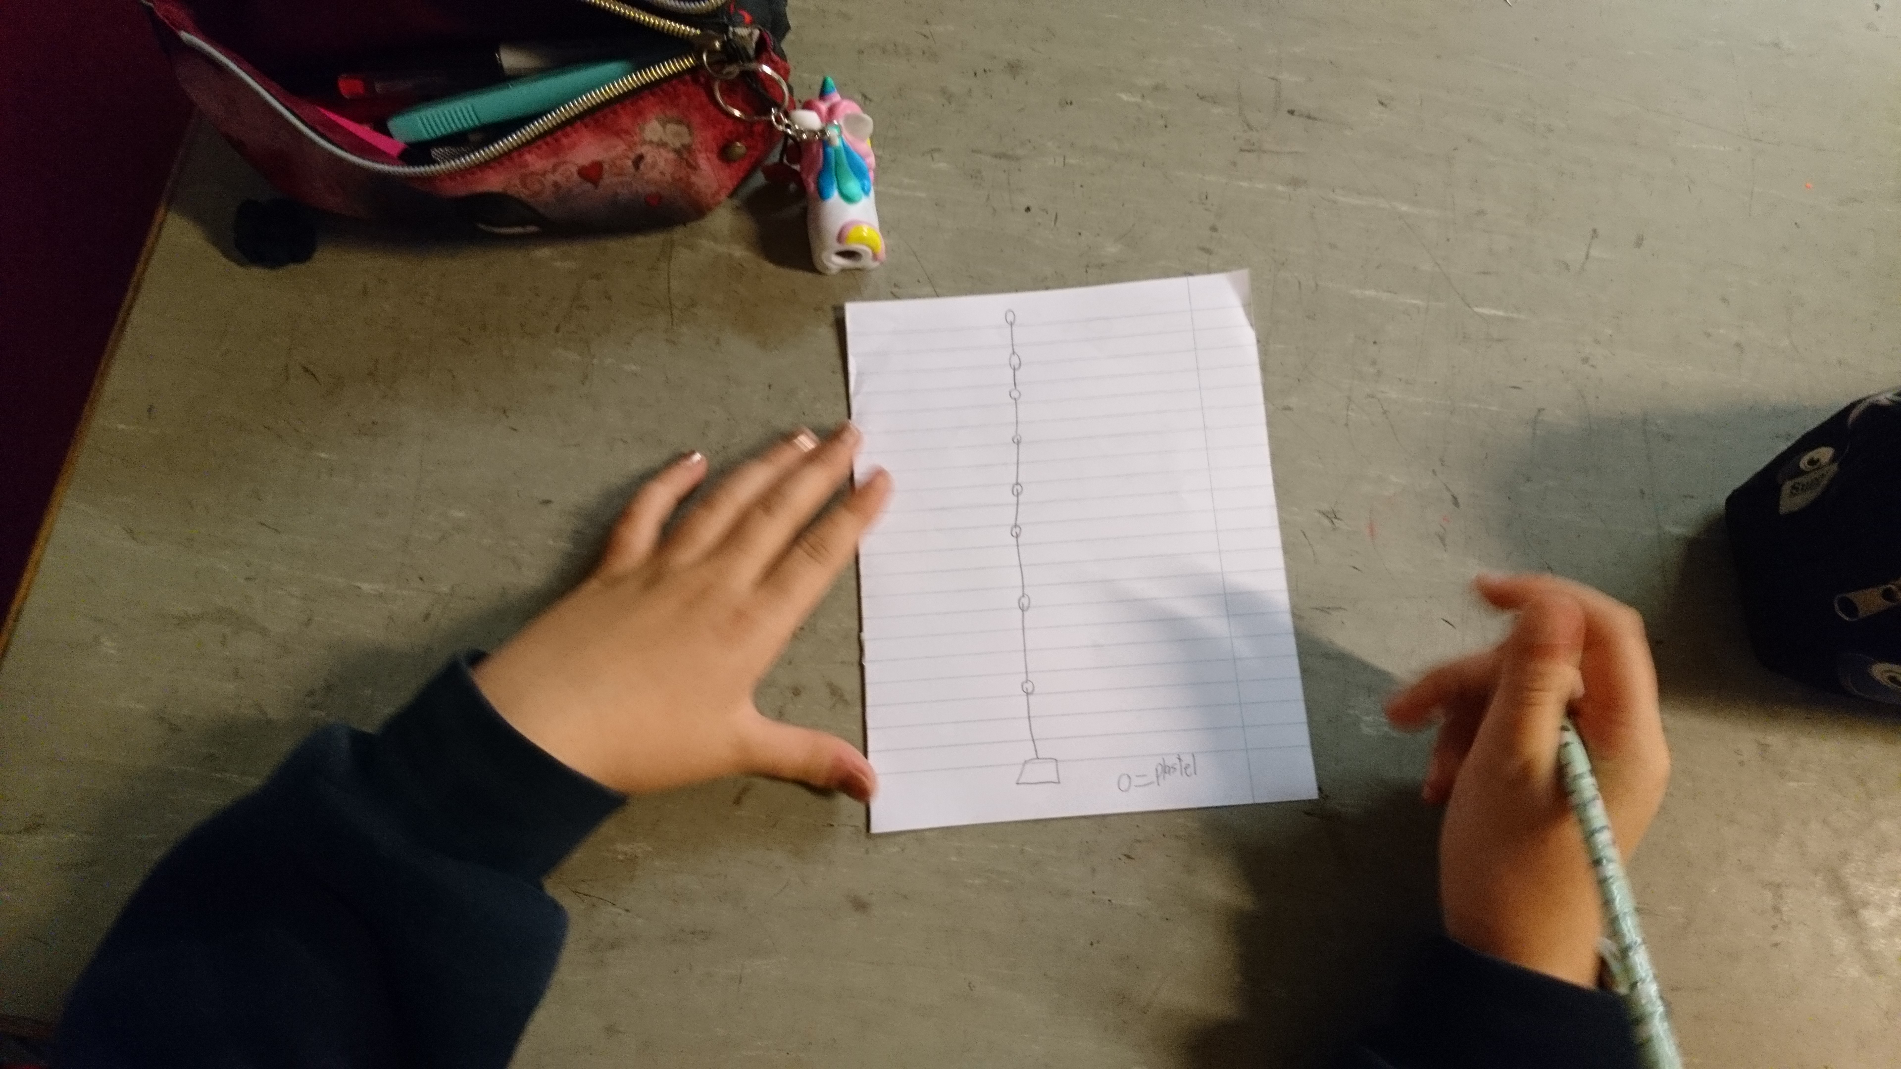

  - Getting Creative
Use the resources available to you online. Open a window and look outside. Delve into your imagination. Creativity will flourish. We can’t wait to see what you can draw / paint / build / mould / sketch.

Art Project 2020

Suggested Activities
There are so many ideas in your own heads that you don’t need these at all! Sometimes though, when we are tired, it is nice to use an idea so you are welcome to this list.
Please send a photo to the
sacredheartspring2020@gmail.com
We would love to see your creativity and if a relative or friend draws, paints or makes, ask them to share it with us also. Recycle, reuse as much as you can
Enjoy.

Drawing:
Why not try drawing a tree on the grass with a brush.
Or a bird on the steamy window with your finger.
Or a picture of a bug on a scrunched up piece of paper that you flattened out, (recycled) You could use crayons, paints, markers, chalk

Construction:
Make a bird-feeder using recycled milk cartons.
Make a bird-house using recycled objects.
Make a bug hotel, with a little guidance, help from an adult. Use natural litter to make an imaginary house.

Printing:
Use a natural object e.g. a leaf, twig, potato, stone to make a print, repeated pattern. Design a stencil to make a print on a nature theme e.g. a feather design, an egg.

Fabric and Fibre:
Use materials and threads to make a collage of a nature scene e.g. a bird, a tree, bugs on a leaf or a bark.
Use fibre / threads to make a web in a branch, be very careful not to harm any little creatures or bugs.
Using fabric to make a plait and wind it around to make a nest. Then make a pompom bird to sit inside.!

