 | Scoil an Chroí Ró Naofa Íosa  Class: Sixth | 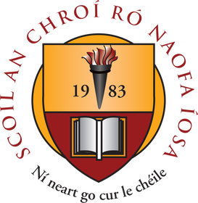

Suggested Work

Activities and Projects
task | Description
Master your Maths | Week 26 – 28 (one per day)
Busy at Maths | Chapter 21 Data 2 and Chapter 30 Data 3
Just Grammar | Next 4 pages (follow on from page marked)
Spellbound | Next two weeks: Week 26 and Week 27
Irish | Continue to revise ALL verbs (3 tenses) and re-read vocabulary lists
Religious Ed | My Confirmation Book – Learn Mass responses. Complete pages 40 – 44
Music | Listen to the next composer available on www.classics4kids.com
PE | Daily PE Lessons by Joe Wicks on www.youtube.com

Novel and Reading
task | Description
Read at Home | Week 24 – Read one page per day and answer questions in your copy. Book available on www.cjfallon.ie.
Diary | Keep a daily diary on how life has changed for you and your family during the restrictions put in place as a result of the corona virus

Online Material

- Twinkl online (open access)
- Oxford owl online (novels and reading material)
- Khan Academy
- GoNoodle (online exercises and movement breaks)
- Scoilnet
- Joe Wicks body coach online
- E-Leathanach
- Classics for Kids
- Seidean Sí (6th)
- Kahoot online
- www.cjfallon.ie
- www.folensonline.ie

