 | Scoil an Chroí Ró Naofa Íosa  Class: Sixth | 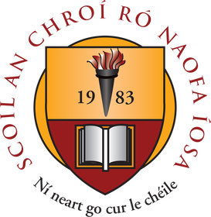

Suggested Work

Activities and Projects
task | Description
Master Your Maths | Next 3 weeks (1 per day).
Busy at Maths | Capacity (pg. 172), Weight (pg. 162), 3D Shapes (pg. 168). Read, explore and complete activities.
Just Grammar | Next 4 pages (follow on from page marked).
Spellbound | Next 3 weeks.
Irish | Revise all verbs (3 tenses) and re-read vocabulary lists.
Religious Education | My Confirmation Book – learn Mass responses.
Music | Listen to the next composer available.

Novel and Reading
task | Description
Book Reviews | Read two novels of choice (hardcopy or online). Complete two book reviews.
Project:  A country of your choice | Explore a country of the world and complete a project (slideshows or online presentations are encouraged where possible). Examine the following key features:  1. General Facts. 2. Famous Tourist Sites. 3. Famous People. 4. Geographical Features (rivers, lakes, mountains etc). 5. Industry and Economy.

Online Material

- Twinkl online (open access)
- Oxford Owl online (novels and reading material)
- Khan Academy
- GoNoodle (online exercises and movement breaks)
- Scoilnet
- Jo Wicks body coach online
- E-Leathanach
- Classics for Kids
- Seidean Sí (6th)
- Kahoot online

Free subscription for a month is currently available on the excellent www.twinkl.ie website. Visit www.twinkl.ie/offer and enter the code IRLTWINKLHELPS. We highly recommend that you sign up to this website for a wide variety of educational content and activities.

