 | Scoil an Chroí Ró Naofa Íosa  Class: Fifth | 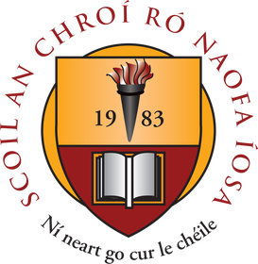

Suggested Work

Activities and Projects
task | Description
Master Your Maths | Week 24 and 25. Revise all multiplication and division tables.
Busy at Maths | Look Back (pg. 119), Chapter 23 Directed Numbers, Chapter 25 Weight.
Just Grammar | Next 3 pages (follow on from page marked).
Spellbound | Units 24, 25 and 26.
Irish | Revise all verbs (A.C and A.L).
SPHE | Friendship activities on www.Twinkl.ie
Music | Listen to the next composer available.

Novel and Reading
task | Description
Up and Running | Read and complete activities: ‘The Hat’ and ‘The Superglue’. Complete two book reviews based on library books of your choice (online books also available).
Projects:  The Famine  Planet Earth in Space  The Human heart | Explore these topics and create an interesting presentation of facts.

Online Material
- Twinkl online (open access)
- Oxford Owl online (novels and reading material)
- Khan Academy
- GoNoodle (online exercises and movement breaks)
- Scoilnet
- Jo Wicks body coach online
- E-Leathanach
- Classics for Kids
- Seidean Sí (5th)
- Kahoot online

Free subscription for a month is currently available on the excellent www.twinkl.ie website. Visit www.twinkl.ie/offer and enter the code IRLTWINKLHELPS. We highly recommend that you sign up to this website for a wide variety of educational content and activities.

