 | Scoil an Chroí Ró Naofa Íosa  Class: Third | 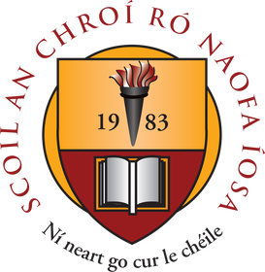

Suggested Work

Activities and Projects
task | Description
Master Your Maths | Continue for the next 3 weeks and complete associated tests at the back of the book.  Revise tables.
Mathemagic | Chapter 28 Pattern (pg. 147). Chapter 30 Weight (pg. 156).
Just Grammar | Next 3 pages (follow on from the page marked).
Spellbound | Next 3 units.
Irish | Read and revise hardback copies focusing on songs, poems and grammar.
SPHE | Friendship activities on www.Twinkl.ie  Read over Weaving Wellbeing (Emotion Potion).
Music | Listen to the next composer.

Novel and Reading
task | Description
Book Review | Write one book review on a book of your choice.
Projects:  1. Australia  2. Australian Wildlife | Explore these topics and create an interesting presentation of facts.

Online Material

- Twinkl online (open access)
- Oxford Owl online (novels and reading material)
- Khan Academy
- GoNoodle (online exercises and movement breaks)
- Scoilnet
- Jo Wicks body coach online
- E-Leathanach
- Classics for Kids
- Seidean Sí
- Kahoot online

Free subscription for a month is currently available on the excellent www.twinkl.ie website. Visit www.twinkl.ie/offer and enter the code IRLTWINKLHELPS. We highly recommend that you sign up to this website for a wide variety of educational content and activities.

